Book Publishing & Distribution

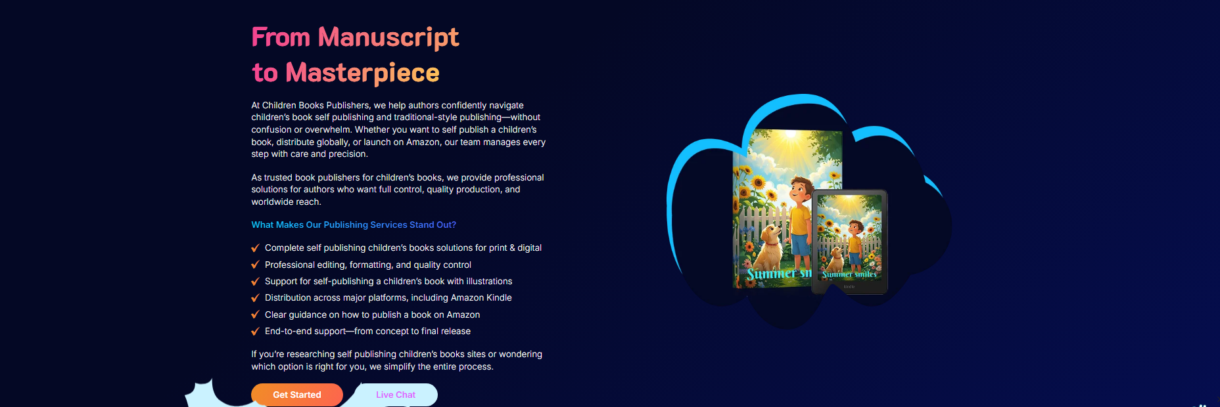

With Our Studio, Sell Your Book On:

Show some more publishing website in this bar
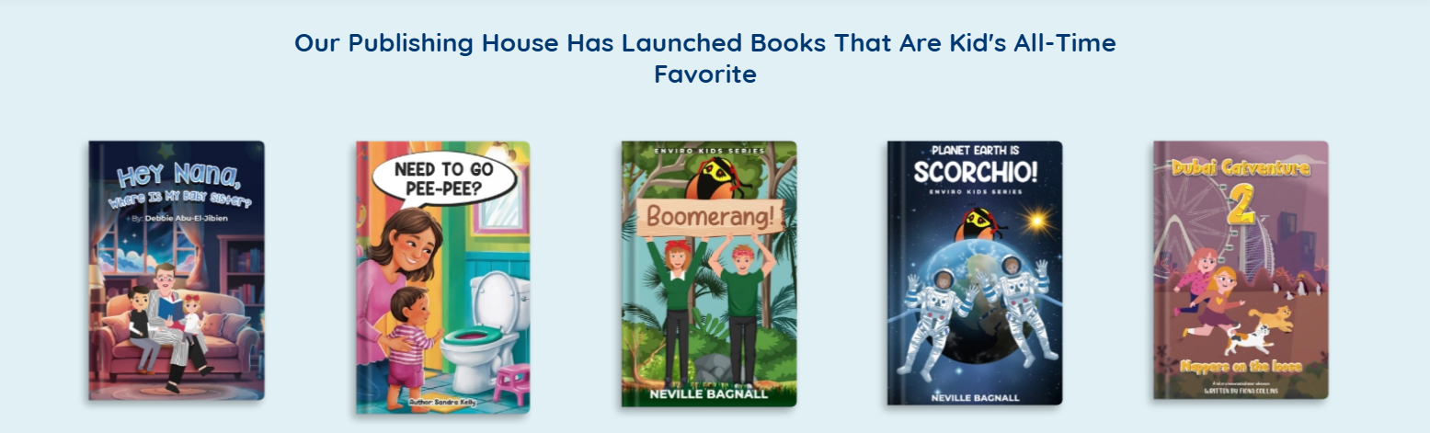

Our Publishing Step by Step Overview
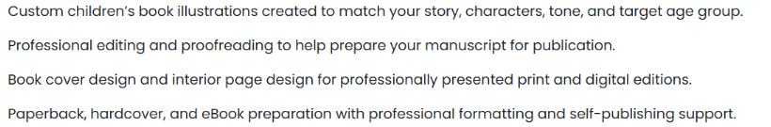
Editing & Proofreading

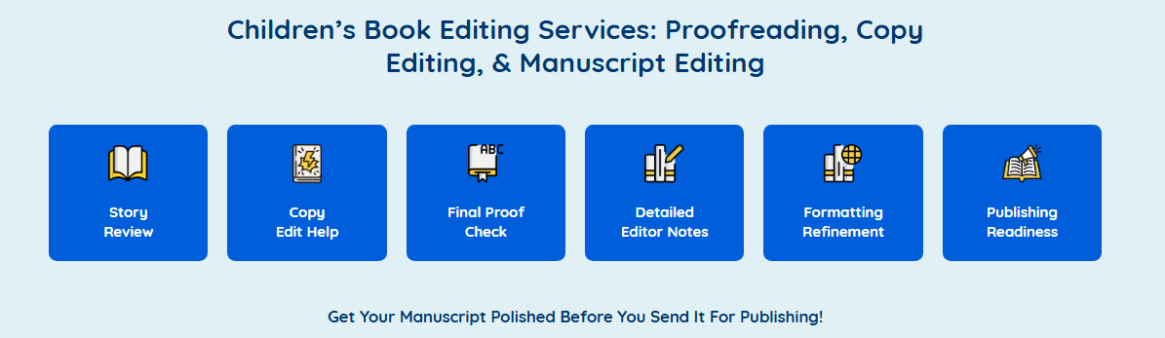

Why Choosing AI Over a Professional Children's Book Editor Could Hurt Your Story
You've spent months bringing your children's book to life, but what if AI editing takes away the magic that makes it special? It can quietly change your characters' voices, weaken the emotions, and take away the little details you worked so hard to create. The worst part? You might not even notice until your story no longer feels like yours. Is that a risk worth taking?
That's why having a professional editor by your side matters. A human editor knows how to keep the fun, imagination, and emotions that make children fall in love with a story. Our professional book editing services help make your writing better without losing the voice and personality that make your book special.
After all, what if your story could become a child's favorite bedtime read? You wouldn't want poor editing to stand in the way. Our professional editing services give your manuscript the care it deserves, so little readers keep asking for just one more page.
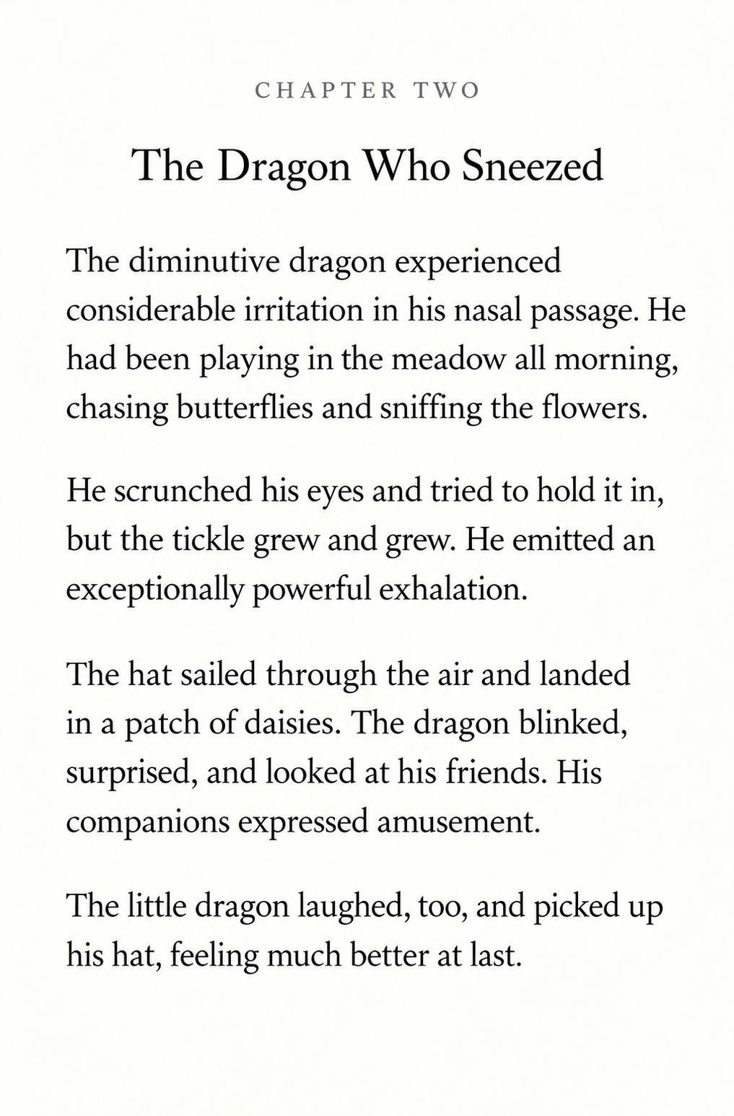
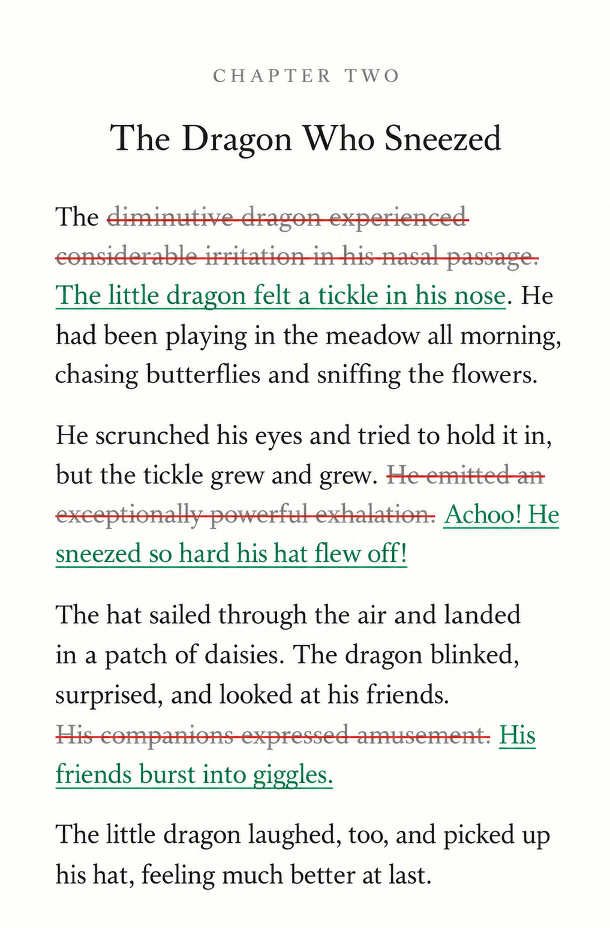

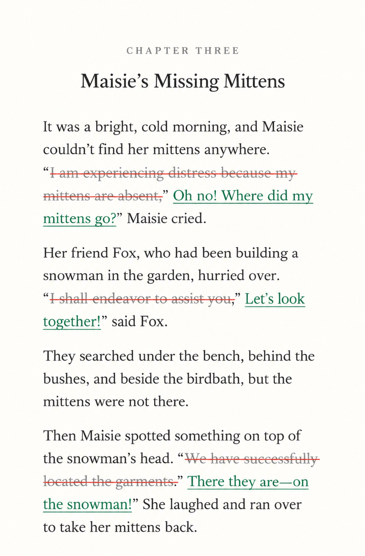
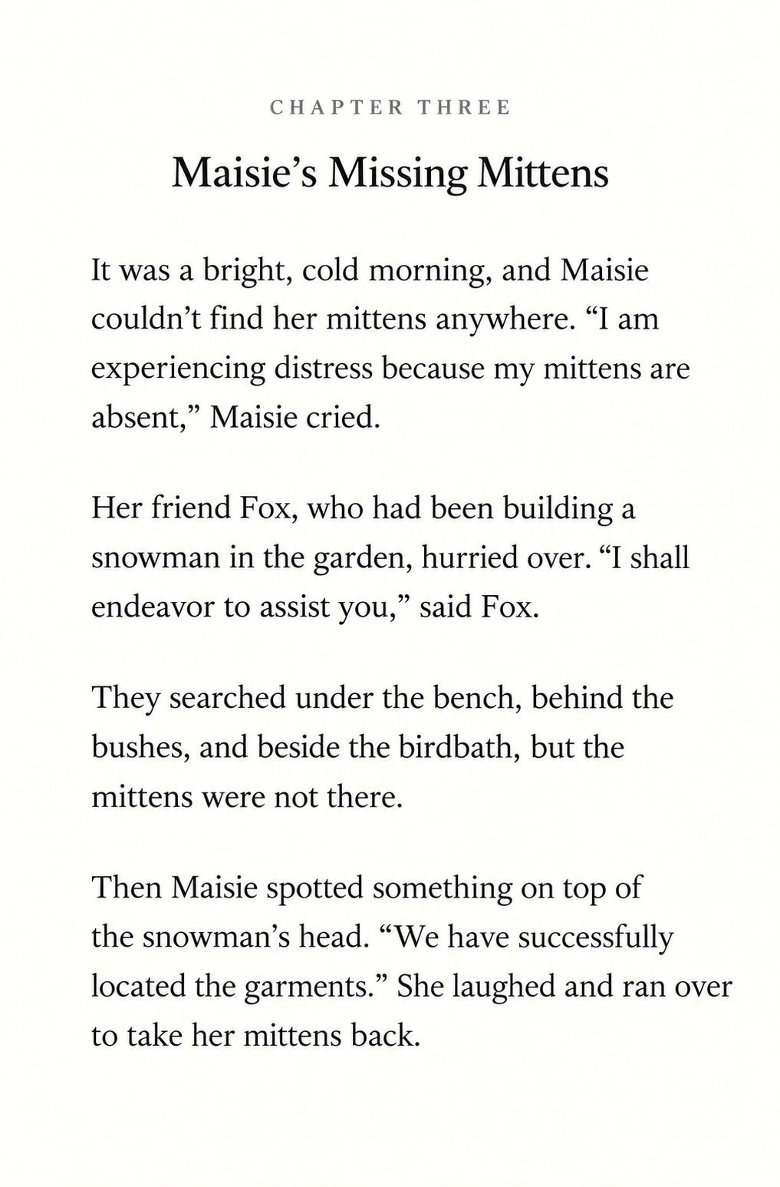

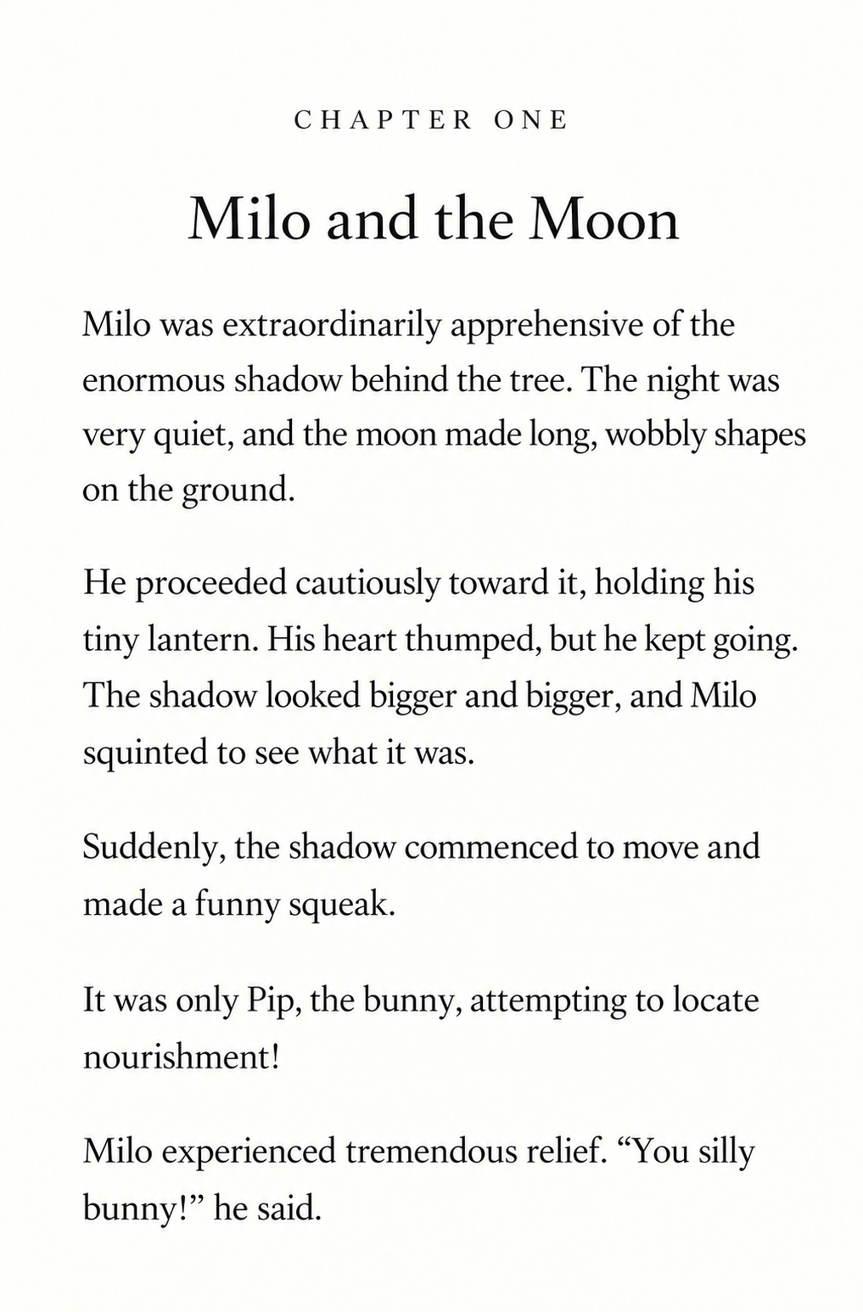
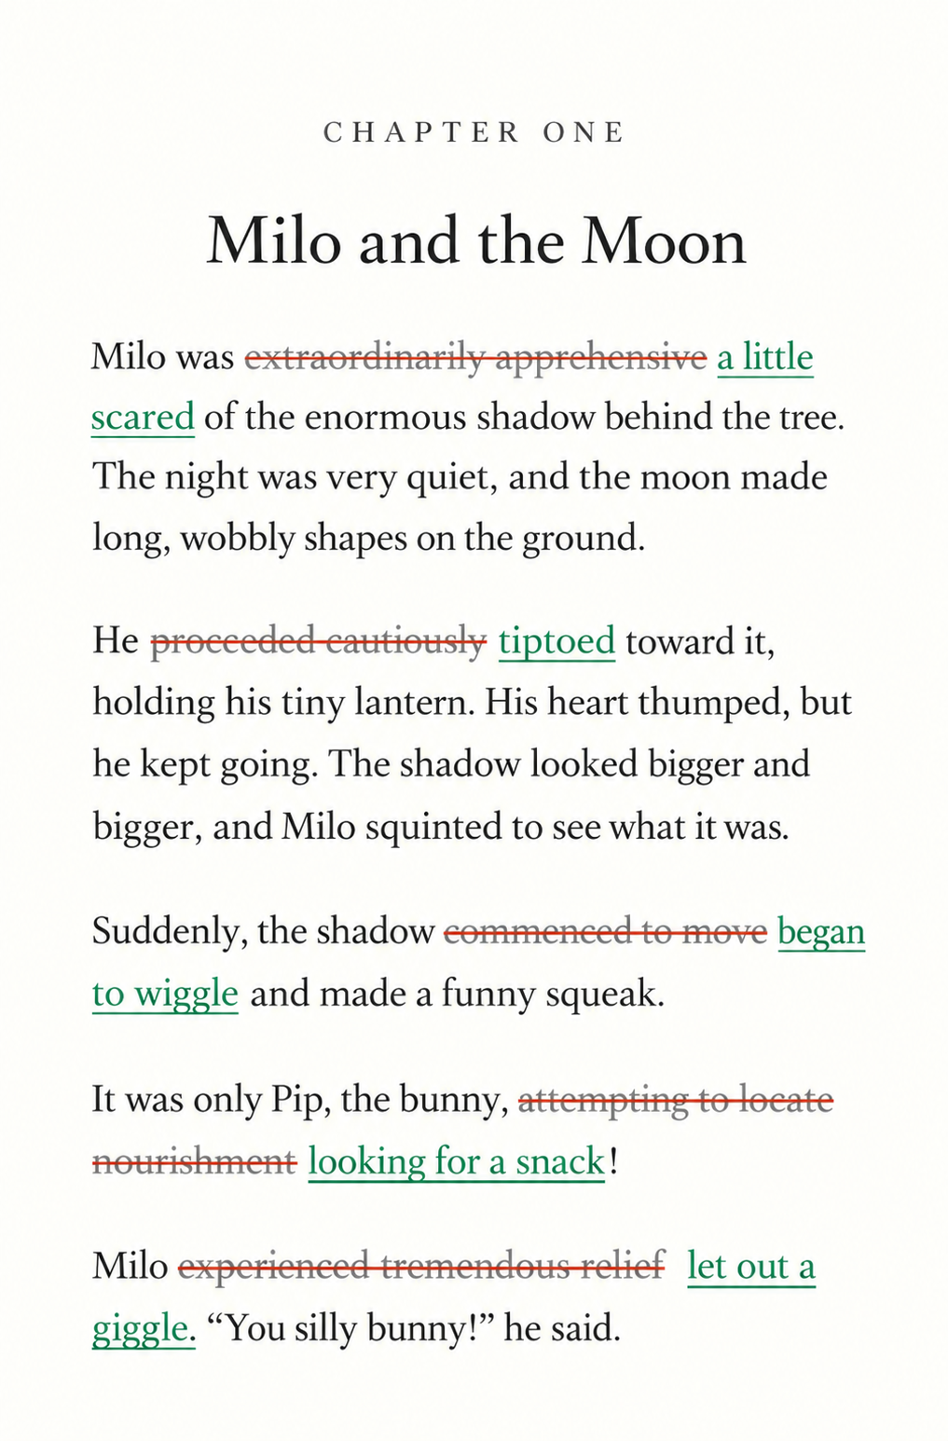

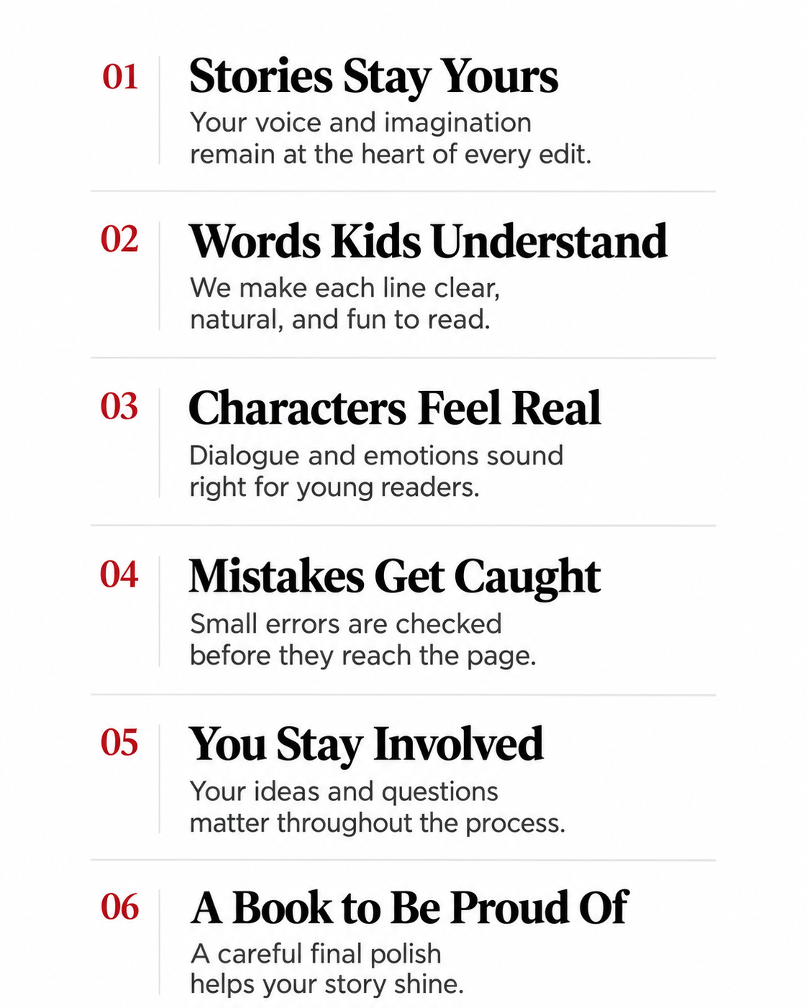
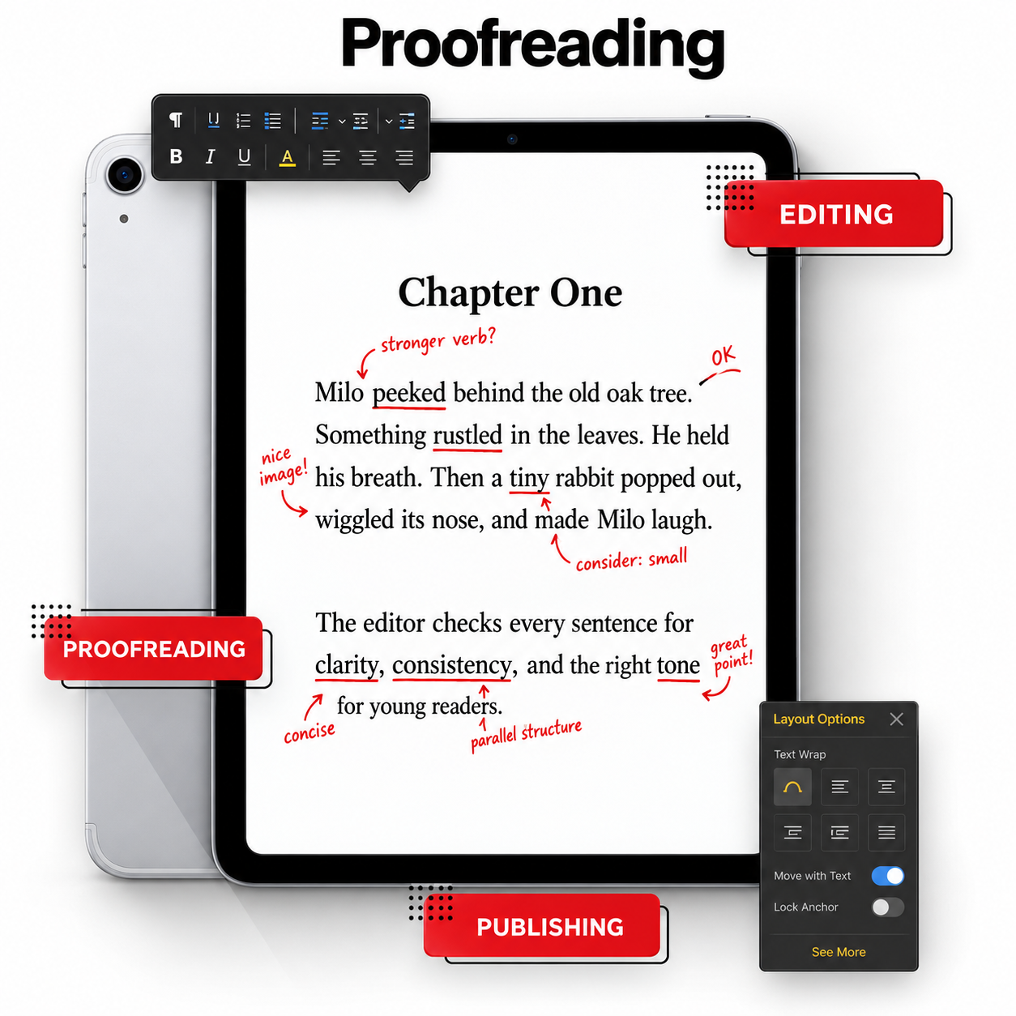

Formatting & Layout Design
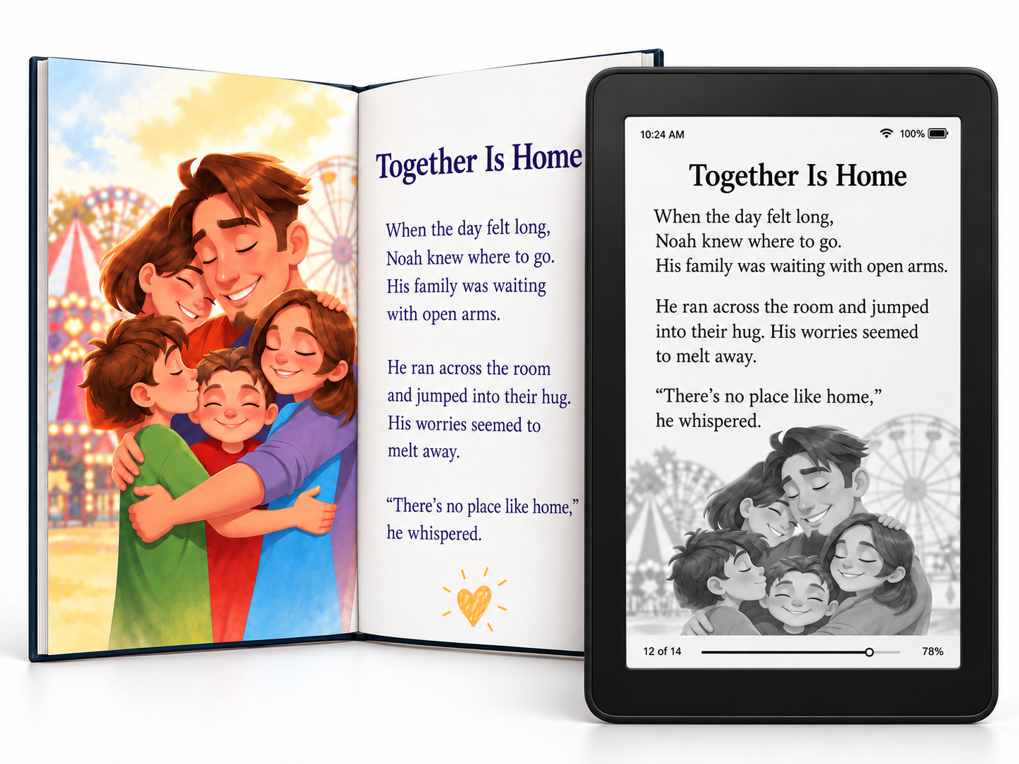
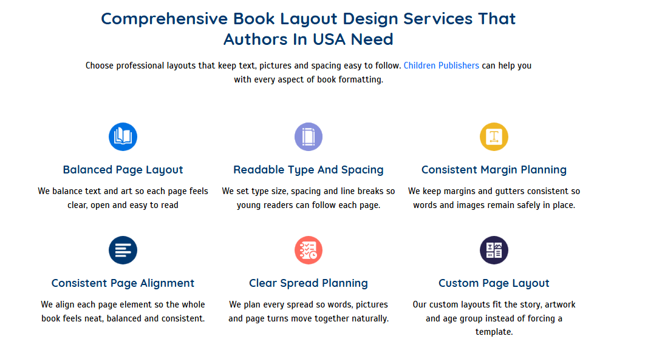

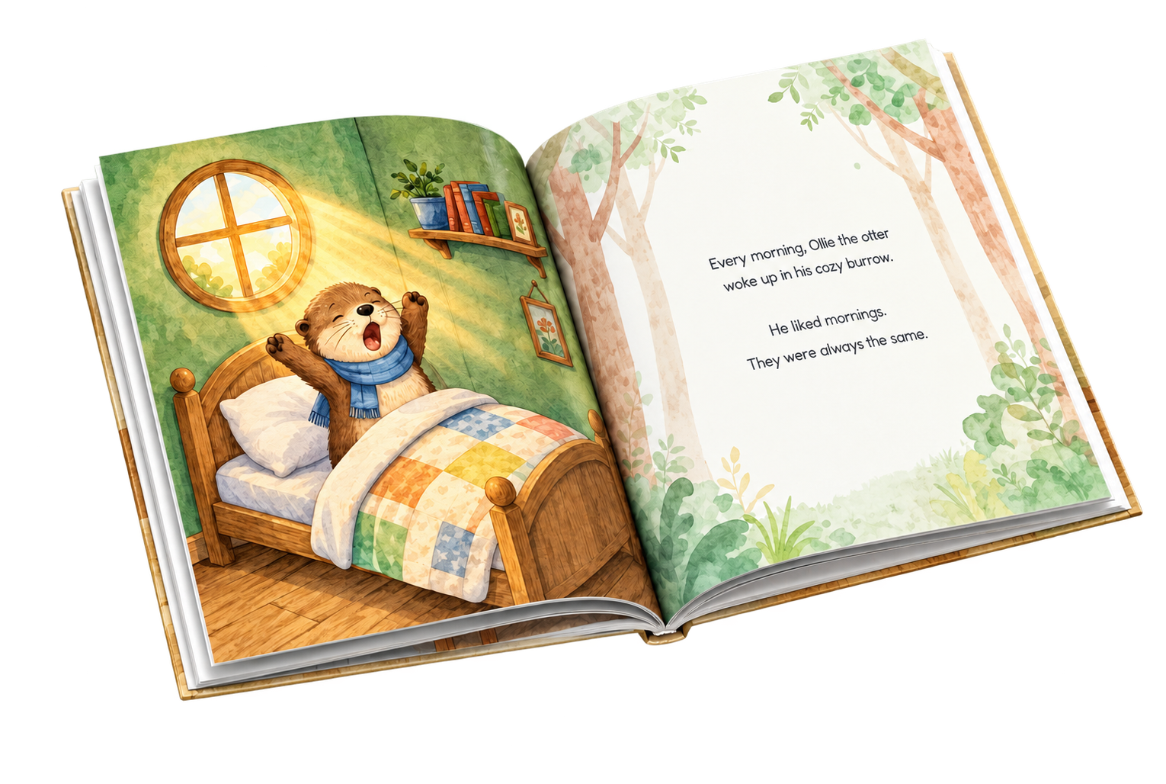
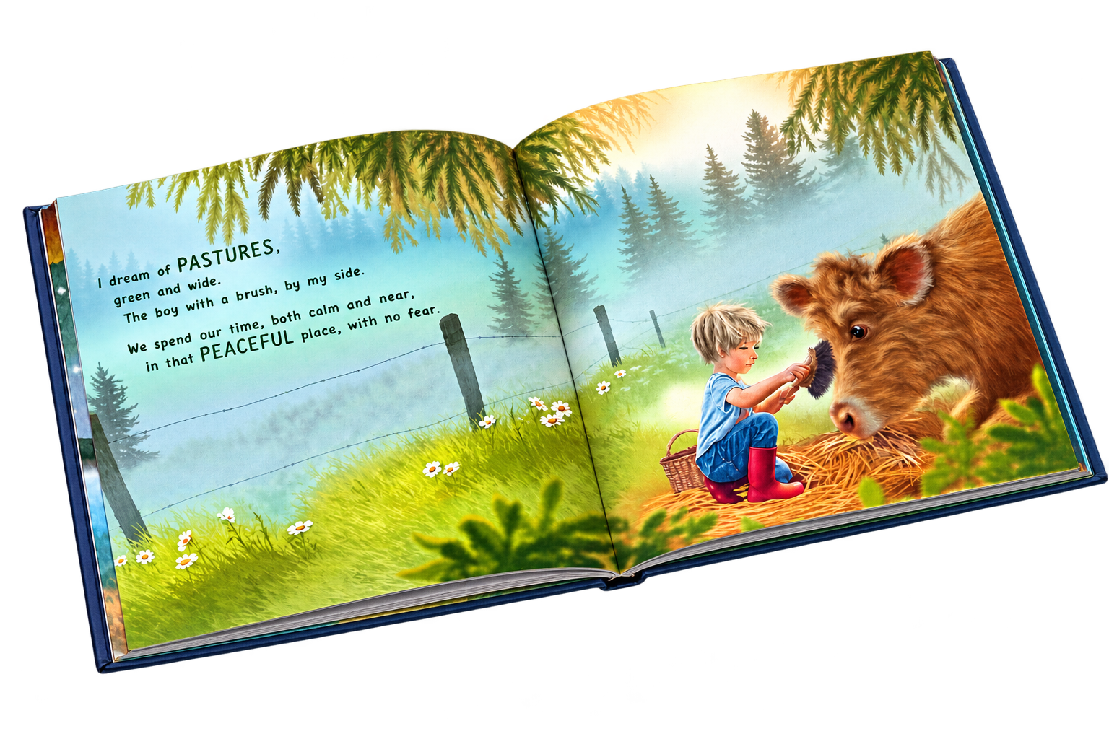

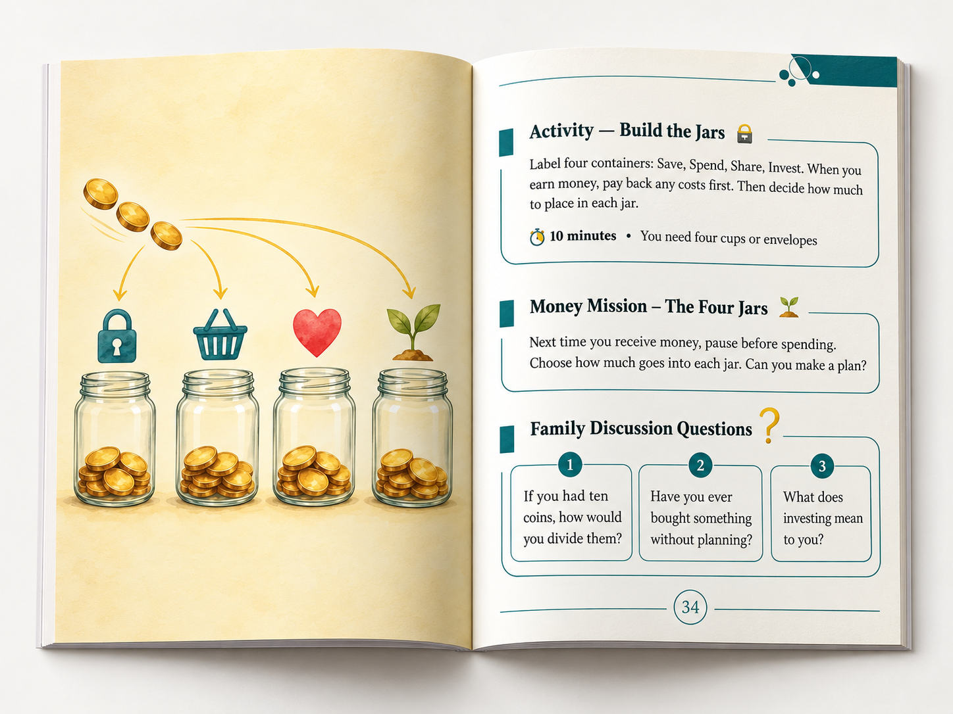

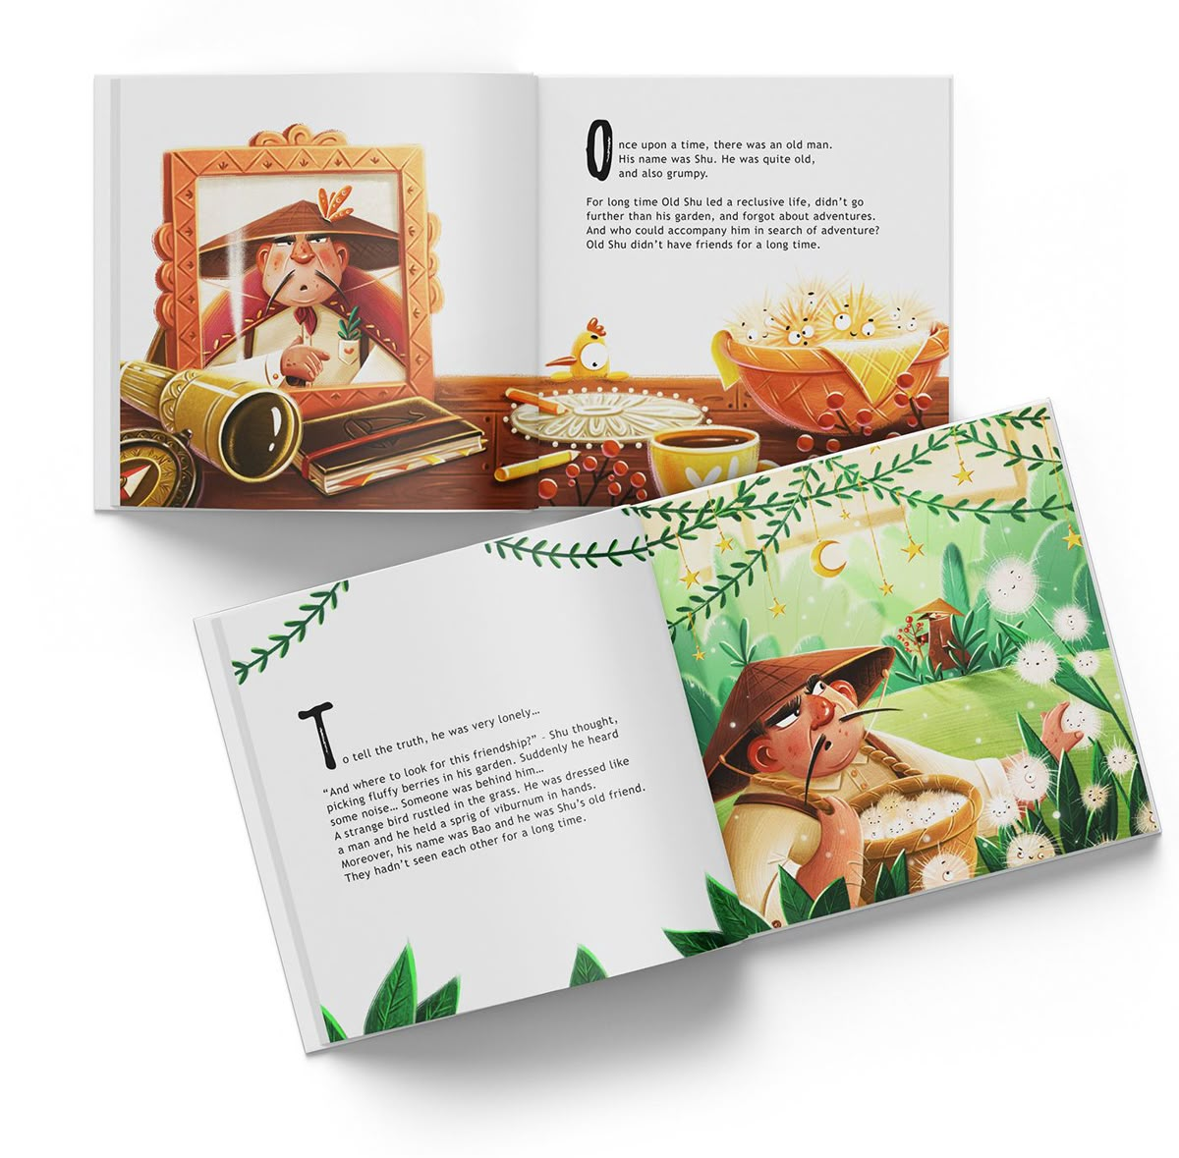
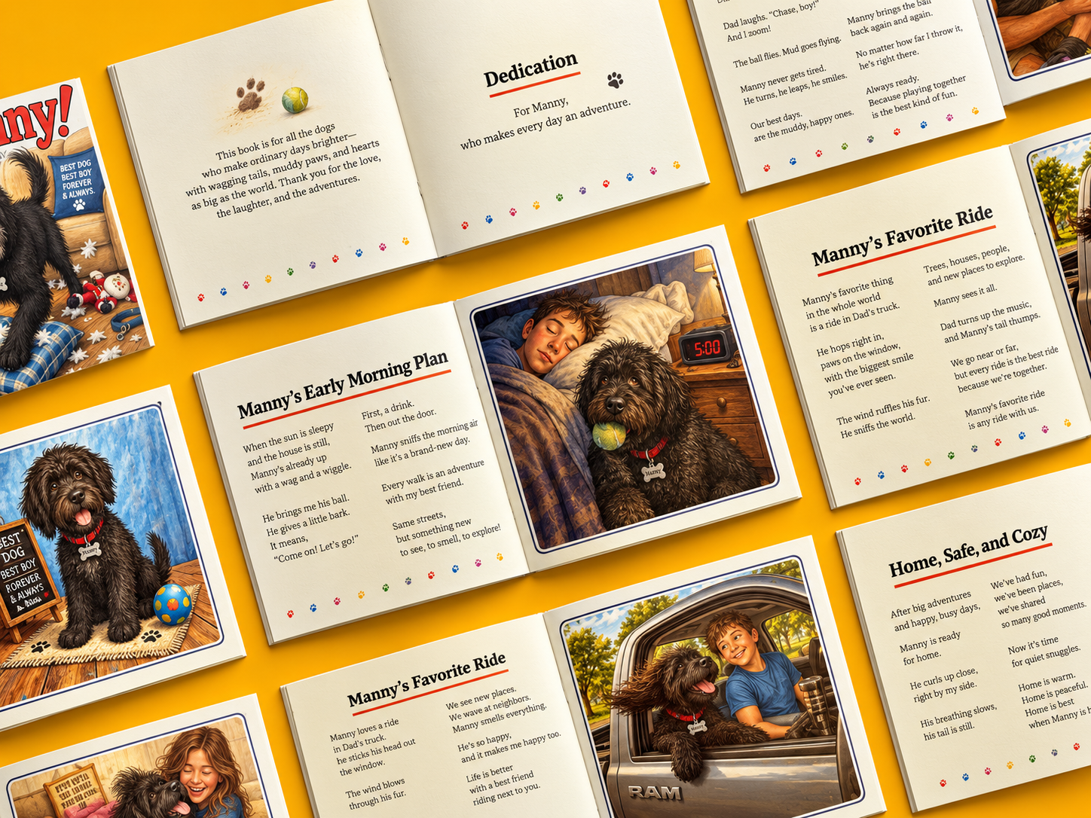
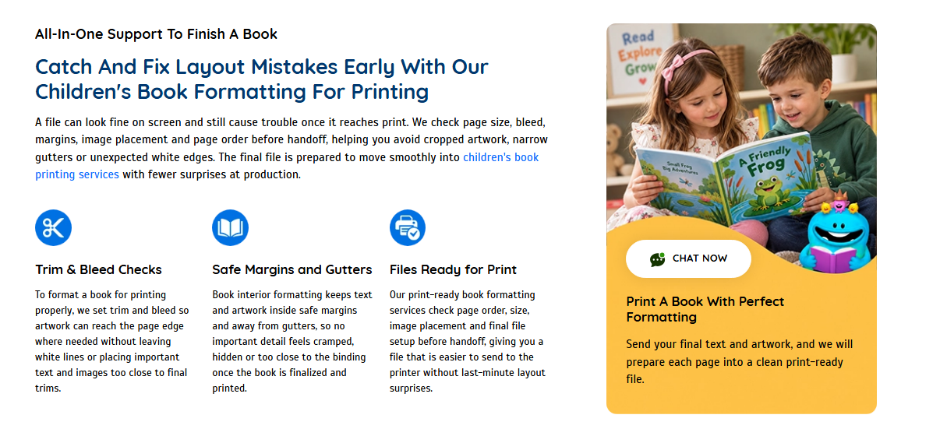
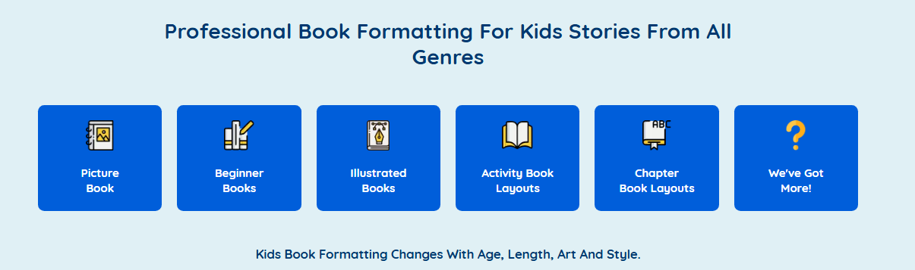

Book Publishing & Distribution
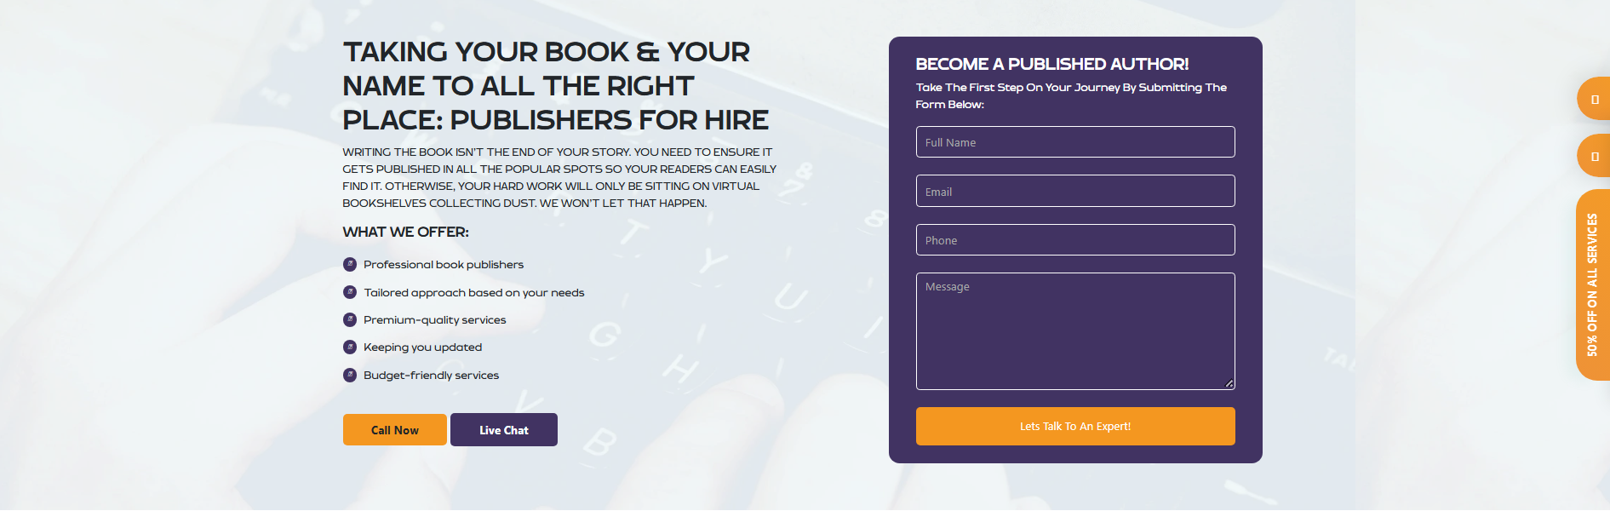
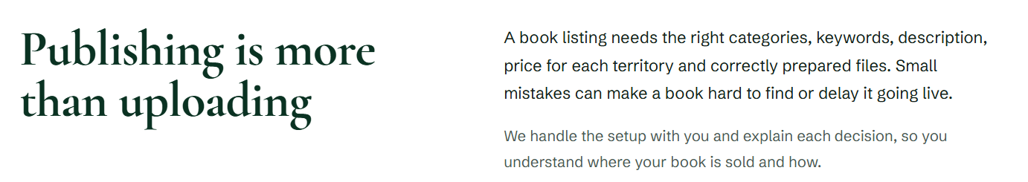
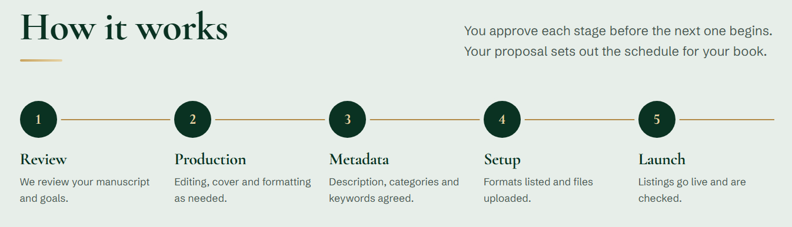

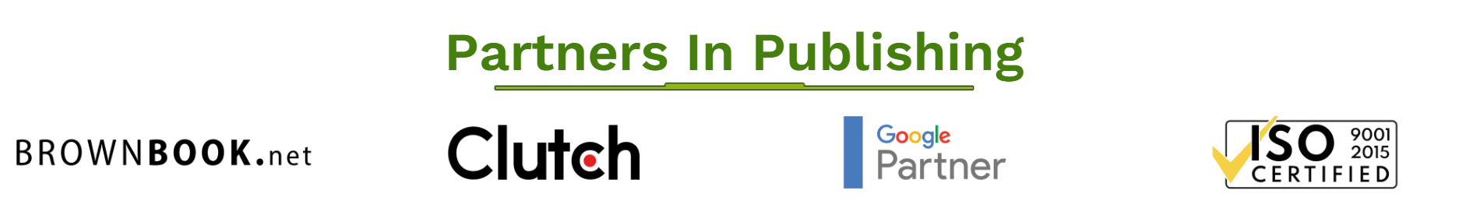
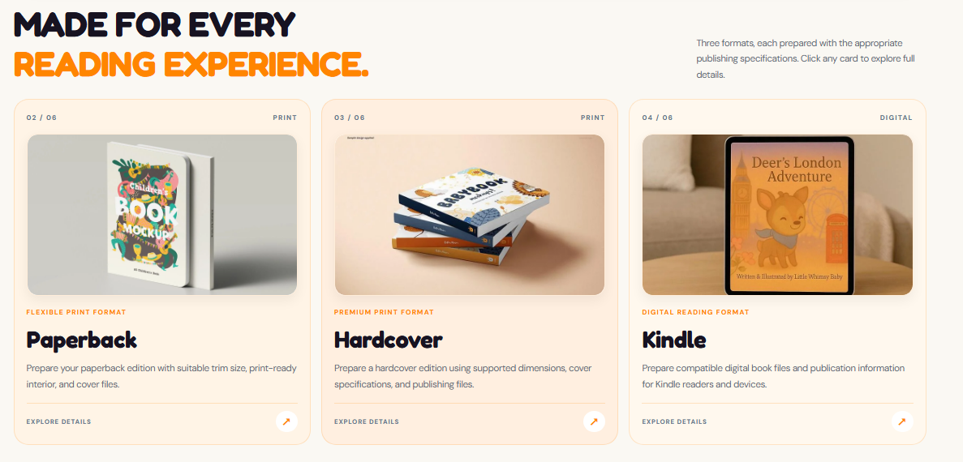
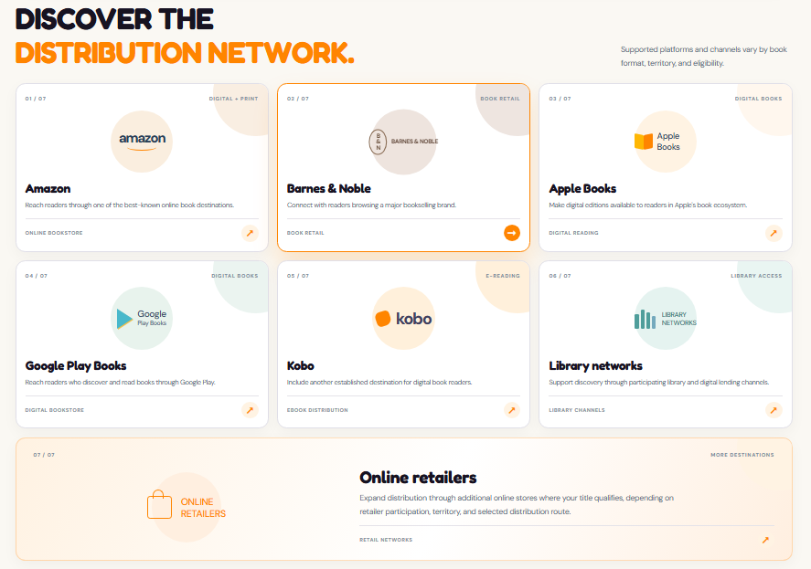

Print on demand, printed only when it sells
Your book stays available in print without stock, storage or upfront print runs.
We prepare your files to print-on-demand specifications and set the book up for online orders.

No stock, no warehouse
With print on demand, each copy is printed when a reader orders it. There is no minimum run, no storage and no unsold books in the garage. The trade-off is fewer format options and a higher cost per copy, so it suits ongoing online sales best.



